

**Tallahassee Community School**

**Return to School Plan September 2020**

|  |  |
| --- | --- |
| **Name of School** | Tallahassee Community School |
| **Grade level configuration** | PP-3 |
| **Principal** | Nancy Liberatore |
| **Student enrollment Sept 2020** | 333 students 34 Pre-primary students Total: 367 |
| **Total number of staff in the building** | 40 (does not include HRM Rec Centre) |

**Overview**

Guiding Principles:

* *Learning happens best when students are in schools with trained staff.*
* All students will be back to school 5 days/week.
* Safety of all students and staff is key. We will honour the following themes:
  + Pre-screening of students and staff
  + Promotion of Physical Distancing
  + Enhanced Cleaning Protocols
  + Contact Tracing Mechanisms
  + Students/staff in cohorts with reduced interactions between cohorts
  + Staggering of transitions/movement in/out and within schools

**Student and Staff Wellness**

|  |  |
| --- | --- |
| Plan when **student** becomes sick during the school day | |
| **Action** | **Location and person responsible** |
| * they will immediately put on a non-medical mask * be taken to a supervised designated location for isolation * the family is contacted to pick the child up * Parents are to call 811 or their Health Care provider to arrange testing and/or other instructions * The areas the student occupied (classroom, sick area, washroom) would be immediately cleaned. | * Teacher notifies the office and the student is directed to put on their non-medical mask and go there directly. * Upon arrival at the office the student will be taken to the sick room by the Admin Assistant or the Administrator present. * The child’s parents/guardians will be immediately called by the Admin Assistant or the Administrator present and asked to come for pick up. * The child will remain in isolation in the sick room until their drive has arrived and will be supervised by the Admin Assistant or the Administrator present. * If the parents/guardians are unable to pick up the child but are home, the school and the parents/guardians will come up with a plan on how to get the child home as quickly as possible. * The sick room will be sanitized by the custodian as soon as the child has been picked up or before any other student occupies the space. |
| Plan when **staff** becomes sick during the school day | |
| **Action** | **Location and person responsible** |
| * they are to put on a non-medical mask immediately * notify the office that they will need to leave * Proceed to a location for isolation, in conjunction with support from the office * Area that was occupied is cleaned * leave the building as soon as possible. * Staff member will call 811 to arrange testing and/or other instructions | * The staff person feeling sick from any employee group will immediately notify the Principal or Vice Principal of their condition. * The staff person will also be responsible to put their mask on at this time and isolate themselves in the staffroom. * The Principal or Vice Principal along with the Admin Assistant will immediately begin looking for a   substitute teacher.   * The Principal or Vice Principal will make sure the class is supervised * Students will practice hand hygiene. * The Day Custodian will begin sanitizing the classroom as soon as the students have left. * The class will continue working on the teacher’s |

emergency substitute plan tasks.

* The staff member will leave the building as soon as they have made arrangements to go home.
* If there was a need for the staff person to isolate in the staffroom, the day custodian will sanitize this area once finished sanitizing the classroom.
* The Employee will continue to let administration know each day the update of their condition and as to whether or not they have had to be tested for Covid.
* Administrators will also do daily wellness checks with staff members each day. This can be for health issues or for stress related issues.

**Pre-Screening of Students and Staff**

|  |  |
| --- | --- |
| **Pre-screening of Students** |  |
| * Parents will screen their child before sending them to school * At school | * All Staff will be required, especially homeroom teachers, to remain vigilant for signs and symptoms of COVID-19 among their students each day. |
| **Pre-screening of Staff** | **Responsible for Record Maintenance** |
| * Staff will monitor their health and notify admin if they have symptoms of COVID-19 | * The Principal will be responsible to go over go over protocols around staff becoming sick. |
| **Visitors** | **Location, set up and person responsible** |
| * No visitors inside the building except essential employees * Sign in form for HRCE staff, e.g.   lunch monitors, Operations personnel   * Essential employees will practice hand hygiene before being escorted to their location in the building | * The visitor who wishes to speak with the principal or vice principal can contact them by phone or email. Contact information:   902-465-8651 [nliberatore@hrce.ca](mailto:nliberatore@hrce.ca) [rutledget@hrce.ca](mailto:rutledget@hrce.ca) |

**Personal Protective Equipment**

|  |  |
| --- | --- |
|  | **Situation** |
| Students  It is mandatory to wear a non-medical mask on the   * School Bus | **Other as applicable -**  Depending on regulations and suggestions from NSPH at the time, students will be expected to wear non-medical masks following those regulations. The current recommendation is that students in grades PP-3 will wear non-medical masks on the bus.  Students can chose to wear a mask at school but it is not mandatory at this time.  Each student will receive 2 non-medical masks on the first day of school |
| Staff  When in areas where reasonable physical distancing is not possible, it is **strongly recommended** that staff wear non-medical masks.   * Close contact with students * Lockdown * Fire drill * Moving between cohorts   + Practice good hand washing   + Maintain records of cohorts visited   + Wear PPE when necessary | **Other as applicable -**   * Staff will follow the direction set out by NSPH at the time. The current recommendation for staff is that they wear masks when physical distancing cannot be maintained. * Some staff will need to transition between cohorts such as custodial staff, resource teachers, music and phys. ed. teachers. As shown in the opposite box, enhanced protocols will need to be followed with these staff members. |

**Physical Distancing and Cohort Considerations**

*Cohort - A subgroup of the school that will, whenever possible, remain isolated from other cohorts. The cohort concept encourages individuals who cannot maintain 2 metre physical distance when in group settings to interact with the same people within their own cohort group. These groups are defined for our purposes in order to better organize our students into recognizable groups that will facilitate contact tracing as well as mitigate the unnecessary cross-contamination throughout the overall student body.

|  |  |
| --- | --- |
| **Cohort Construction**  *\*When students are within their cohorts, physical distancing will still be encouraged when possible.* | |
|  | **Cohorts**   * Each classroom is a cohort * We currently have 16 classrooms and 2 pre-primary classrooms. |

**PLEASE NOTE:**

Students will be spending more time outside than in typical years. Please provide your child with a hat and sunscreen and possibly sunglasses especially in September where we do get some hot days. It is a good idea to pack a sweater, as it can get quite windy at our location. Please label every article of outwear with your child’s name so it can be returned to your child should it be misplaced on the bus, field, playground and classroom. Thank you!

**Student Transitions**

|  |  |
| --- | --- |
| Arrival |  |
| *Staggering of times when possible | **Bus -**   * Several buses arrive at the school each morning. (exact number not known at time of distribution of doc.) These buses arrive between 8:15 and 8:30 a.m. Only one bus will be allowed to unload at the Main Entrance loop at a time. Student will go directly to their classrooms. **Bussed students only will enter and exit the building through the Main Entrance Doors**. Walking students will be assigned a door (#1, #2, or #3) to enter and exit the building depending on their classroom. (This list is at the end of this document.)   Each set of doors will be supervised by a staff member where students will be welcomed but also watched for signs and symptoms of COVID-19.  **Parent drop off-**   * Will occur each morning **after 8:15 a.m**. Parents are encouraged to park on Oceanlea Drive, if necessary to drop off a student. Students will enter the building at the appropriate supervised doorway for their class. * If parents choose to drive into the parking lot, please drop and go. Parents will not leave their vehicle during this time. This allows for less crowding and continuous traffic flow. * *Pre-primary parents will receive direction from pre-primary staff on where to drop off and pick up students.   **Walkers-**   * Walking students are permitted on school grounds after 8:15 a.m. Walking students will go to their assigned door and directly to their classroom where they will sanitize their hands. Doors will be supervised by a staff member. |

|  |  |
| --- | --- |
| Departure |  |
| *Staggering of times when possible | **Bus -**   * **Specialist teachers will lead bus students to their buses** starting at 2:25 and ending by 2:40.   **Parent Pick Ups-**   * Will occur during a specified time immediately following the loading of the buses. Walking students will remain in the homeroom class until bus students have been dismissed. Parents/Caregivers can wait by the designated door their child is using, socially distancing from other adults.   **Daycare Pick Ups-**   * Will occur before and during bus dismissal   **Early Pick Ups-**   * I encourage you to minimize late drop-off and early pick up as much as reasonably possible. If you do need to come to the school to pick your child up before 2:30 p.m. you need to call the office at 902-465-8651 and set up a time for pick up. We will then have your child meet you at a designated door when you arrive. |

|  |  |
| --- | --- |
| Class to class  *Staggering of times when possible | **Ex. No movement of classes outside of the cohort zone except for specialist-**   * For the 2020-2021 School Year, students will not be travelling with their homeroom teacher to music or phys.ed. Instead, the specialist teacher will conduct music in the homeroom classroom and the phys. ed. teacher will pick up students from their classroom and take them outside as much as possible. On rainy days phys. ed. will take place in the gym while following guidelines set out by the NSPH, or in their homeroom classroom. * Resource, ELS, and LC will also directly pick up students this year if they need them to go to a location other than their homeroom class. |
| Washrooms  *Staggering of times when possible and limiting numbers | **Things to consider -**   * Each class will be scheduled into washroom breaks before or after recess and before and after lunch. * When an individual student needs to use a washroom, they will be asked to go directly to their assigned washroom and only enter when it is not at its maximum capacity. If there is a socially distanced lineup, they will be taught to return to class and try going again at a later time (as much as reasonably possible with little ones). * Teachers will ask students if they need to go to the washroom during non-peak times to alleviate crowding in the washroom and hallways. * Students who have sinks in their classroom will be asked to use that sink for handwashing, as much as possible, to help with overcrowding in the other washrooms. |
| Water bottles | **Things to consider -**   * Parents/guardians are asked to send in a full, reusable water bottle with their child’s name clearly marked on it. Fountains will not be encouraged as they are a high touchpoint surface. If your child requires more than one full water bottle during the school day, please send in two. Students will take their water bottles home each day to be cleaned. |

|  |  |
| --- | --- |
| Hand Washing/Sanitizing | * Handwashing / Sanitizing will be extremely important at many times during the day but especially at snack or lunch times. Washroom/hand washing breaks will be scheduled for each class. * Hand sanitizer will be available in classrooms to help avoid the high volume of students needing handwashing at these times. * Students are encouraged to bring their own hand sanitizer (not too strongly scented) with their lunch containers. |
| Hallways  *Staggering of times when possible | * Scheduled Washroom Breaks, Specialist Teachers going to classes and such will help to eliminate many people being in hallways at a similar time. * Arrows will be used to show proper directionality or traffic flow in the hallways. |
| Breaks  *Staggering of times when possible | **Breakfast Program -**   * All Breakfast program food items will be delivered to homeroom classes as per usual in 2019-20. We will serve individual, prepackaged items as much as possible e.g. Cereal bars, cheese string   **Snack -**   * Students will have brought snack items into classrooms in the morning. * As mentioned above, students will have had a scheduled washroom, handwashing break prior to their snack time. * All students will be able to remain in classrooms during snack time. |

|  |  |
| --- | --- |
|  | **Recess -**   * **Cohort Recess:** * Once outside, this will mean that the playground will be divided into distinct zones. Each cohort will be assigned to one of these zones. * Teachers will choose a time to take students outside for recess, weather permitting * Students will return to classes through the doors assigned to their cohorts at the end of recess. * Teachers will supervise their students at recess time * Students will sanitize their hands after playground equipment use   **Lunch -**   * Students will eat lunch anywhere between 11:05 a.m.- 12:50 p.m. We will have a staggered lunchtime. * Students will remain in classrooms to eat lunch. * For the 2020-2021 school year, we will not have Healthy Hunger options at the start of the year but may reevaluate later. * Handwashing or hand sanitizer use will occur following the washroom/handwashing schedule before the lunch period begins for students. * Please send your child to school with a lunch and the utensils required * Please do not drop lunches off during the school day, as much as reasonably possible |
| Classroom Supplies | * Parents/Guardians are asked to send in basic supplies (one of each item requested) on the first day of school. Teachers will send a note to parents about materials that are required as needed. Teachers do not have space in their classrooms to store all the school supplies requested. Students will have their own supplies and are not permitted to share with others. * Parents are asked to label all school supplies with their child’s name * Students will have their own math manipulatives as required * Library books will be distributed to students and remain at the school * Leveled reading books will be assigned to students for a week and then switched after 72 hours of not being touched |

**Custodian/Cleaner - Enhanced Cleaning and Disinfection of Shared Areas and Surfaces**

*Shared Chromebooks, sporting equipment, library books, etc.

|  |  |
| --- | --- |
| What needs enhanced cleaning protocols | **How will this be addressed** |
| Shared desks – students working in specialists rooms i.e. guidance room, ELS, Reading Recovery | * Teacher will spray each desk with disinfectant and will wipe down desktop and properly dispose of paper towel. |
| Chromebooks | * Will occur based upon protocols as outlined by NSPH and HRCE * Will have to be sanitized in between cohorts. |
| Sporting Equipment | * Phys. Ed. classes will be encouraged to use as little equipment as possible for the 2020/2021 school year and will be encouraged to have phys. ed. happen outside as much as possible. * If equipment is used, it will have to be sanitized in between cohorts. |
| Musical Equipment | * Music classes will be encouraged to use as little equipment as possible for the 2020/2021 school year. * If equipment is used, it will have to be sanitized in between cohorts. * Music classes will be held in individual classrooms. * Use of shared instruments and singing is not encouraged at this time. * Music teacher will teach students to make their own instruments at school |
| Library Space  *Items returned have to be quarantined for 72 hours | * Library books will be delivered to classrooms * Library books will be distributed to students and remain at the school * Staff who are shelving books will need to wash their hands or sanitize, prior to this activity and afterwards. |

**Extra-Curricular**

|  |  |
| --- | --- |
| Activities | **Planning needed** |
| Ex. Mass gatherings/ assemblies/ curriculum night | Mass Gatherings:   * Will need to follow the current NSPH Guidelines for mass gatherings. * Many of our mass gatherings may need to be planned in   different ways. For example, Curriculum Night will be delivered in a virtual way this year. Each of the gatherings will have to be assessed as our school year unfolds to see if there are alternate ways to deliver it. |
|  |  |

**Outbreak Consideration**

|  |  |
| --- | --- |
|  | **EECD 3 Phase Approach** |
| Plan should there be a case of COVID-19 in the school  Responses to Changes in COVID19 | * A detailed outbreak management protocol is developed by Nova Scotia Public Health for use by all schools in the region. Any case of COVID within a school setting will be considered an outbreak and we will follow Public Health’s direction.   **As for responding in the moment:**   * As indicated earlier, if a staff member is concerned that a student is exhibiting signs of illness, this will be reported to the school administration for follow-up. * The parents or guardians will be contacted and asked to pick up their child immediately. * Students will be taken to the isolation room, where they will be supervised until they can be picked up by a parent. The student will be provided with a disposable mask to wear while waiting. * The space will be disinfected once the child has departed. * Parents will be required to follow Public Health protocols. The student should be kept home until they are symptom-free for a minimum of 24 hours or they are able to provide a medical note indicating that they can return to school. * Similar protocol will be in place if a staff member in the building has COVID like symptoms. * The province announced a three-phase approach to schools responding to the COVID 19 pandemic. These decisions will be made by Public Health and could potentially be done as needed in particular schools, family of schools, or regions. Below is a description of each phase and how it influences the students and staff at Tallahassee Community School:   **Phase 1** – 100% Participation – all students will come to school each day following Public Health directives.  **Phase 2** – 100% Participation with reduced class sizes for your children – all students from Tallahassee will go to school each day however, they will not all be going to Tallahassee Community School. Most will go to Tallahassee and some classes will be reassigned to go to Island View. In phase two, class sizes are reduced to approximately 15 students to allow for better social distancing. The reduction of class sizes means creating more classes. Our current projections would have approximately 3 classes needing to go to Island View. If this were the case, we would select students from grades 2 & 3 to go to Island View.  **Phase 3** – At Home Learning – all students within a school,  family of schools, region, or province would move to an at  home learning model |

**Staff Considerations**

|  |  |
| --- | --- |
|  | **How will this be addressed** |
| Staff Breaks | * Teachers from different cohorts will need to remain as separate as possible for the 2020/2021 school year. * All staff should practice physical distancing, as this is especially important if teachers from different cohorts interact. If distancing is not possible, it is highly recommended that they wear non-medical masks. * Teachers will be encouraged to take breaks in their workspaces as much as possible. * The staffroom will not be the recommended area for breaks for the 2020/2021 school year. There is a 4 person maximum in the staff room, and in the case of a staff member becoming ill, it will be used to isolate that staff member until they are able to leave. * Staff can choose unoccupied spaces within the school to have their break and/or lunch * The staffroom kitchen can be used for storage and preparation of lunch items. * Dishes should be washed immediately after use by the person who used them, and all surfaces touched be sanitized (i.e. Kettle, fridge door handle, etc.). * Reminder to staff about the need for hand washing before activities like preparation of food at break time. * Depending on number of lunch monitors, teachers may have their lunch time at staggered times. |
| Staff Materials | * Teachers will be expected to clean classrooms of clutter or extra items prior to students beginning the school year. * Staff will store personal items like coats, boots, etc. in their actual workspace this year. * Staff will be asked to keep open beverage containers such as cups out of their classroom this year. |
| Substitute Teachers | * Substitute teachers will receive reminders from AESOP and the HRCE about protocols that are in place. * Substitutes will be asked to arrive early enough to become familiar with school plans and protocols. * Substitutes will have to sign in at the main office and provide a phone number for contact tracing * Substitutes will be required to bring a non-medical mask with them. |

|  |  |
| --- | --- |
| Shared Staff Spaces | * Staff will be asked to eliminate as many touchpoints as possible. * Staff will need to practice physical distancing in shared areas such as the main office, photocopy room, etc. |
| Meetings between and with | * Meetings will need to be thought about strategically this year to evaluate the best medium for it to happen. Questions to consider would be:   + Can they be held virtually?   + Are all participants necessary?   + If held in person, can physical distancing happen?   + Are enhanced protocols necessary, such as PPE? |

**What will Learning Look Like?**

|  |  |
| --- | --- |
| Field Trips and Gatherings | • Our initial learning time will always focus on building relationships and creating a safe and welcoming class community.  • Instructional time will focus on all curriculum areas. A number of curricular areas will be modified, including Music and Physical Education as already indicated.  • As usual, staff will begin assessing the students once they have developed a rapport with their students and the students understand and follow routines. We will meet students where they are in their learning, coming from such a long layoff of in-person learning.  • Students who previously received support through the learning center and resource will be supported in these programs again this school year.  • Students who have previously benefited from scheduled body breaks will continue to receive this support.  • These are unique times, requiring a lot more traditional teaching practices than the ones we have implemented over the past decades. A lot of our students are used to working in a collaborative setting but that will not be possible this year. Staff will aim to create engaging activities that do not require partners, moving around different stations in class or the sharing of material and equipment. This will be a shift from our previous practices but student and staff safety is our number one priority.  • Where possible, classroom windows will remain open for improved air quality. Send your child with a sweater.  • The gym and library will not be open for their usual purposes. The gym will be used for phys. ed. classes on days when the weather is not favourable to hold classes outside.    • Most support teachers will come to students’ classrooms to teach their respective subjects, following hand hygiene expectations, where possible. It may be necessary for some support teachers to use their office space to help with social distancing.  • Under Public Health orders, there will be no field trips or large group gatherings this year. The events cancelled this year include in person curriculum night, in person parent teacher interviews, holiday and spring concerts, dances, spring fair, etc.  • Teachers will reach out to you virtually for curriculum night and parent teacher interviews.  • If Public Health changes the directive on field trips and gatherings at any point during the school year, we will communicate that to families in our monthly newsletter via email. |

This is the plan we have for the doors each class will use to enter and exit the building at morning arrival, break times and afternoon dismissal. Students who take the bus will be going directly to their classrooms via the Main Entrance and, if they take a bus at the end of the day, they will depart via the Main Entrance. This should alleviate a large number of students using the assigned doors at peak times. We will make revisions to this plan, if needed.

|  |  |  |
| --- | --- | --- |
| **DOOR #1** | **DOOR #2** | **DOOR #3** |
| Pre-primary Bishop  Pre-primary Nicolaou  Grade Primary-1 Myles Grade 2 LaPierre Grade 3 Dempsey  Grade 2-3 Snow | Primary Bruce Primary Gordon Primary MacDonald  Primary Perry  Grade 1 Animashaun  Grade 1 Hanley (Comeau) | Grade 1 Francis/Doiron Grade 1-2 Harris Grade 2 Boudreau Grade 2-3 Comeau Shantz Grade 3 Bigg Grade 3 Hodder |

**Request from Music Teacher:**

If families have any extra of the following items, would you please send them in to create individual instruments for each student?

- Plastic Easter eggs that open, to make shakers

- Cleaned 250 ml sour cream, cottage cheese, cream cheese, etc. containers with lids

Thank you so much,

Patricia Marshall-Casavechia

Music Teacher

**Lunchtime**

***To assist with physical distancing and number of confirmed lunch monitors, we will be having staggered lunch breaks. Lunchtime will be at 11:05-11:55 a.m. or 12:05-12:55 p.m. depending on the schedule.

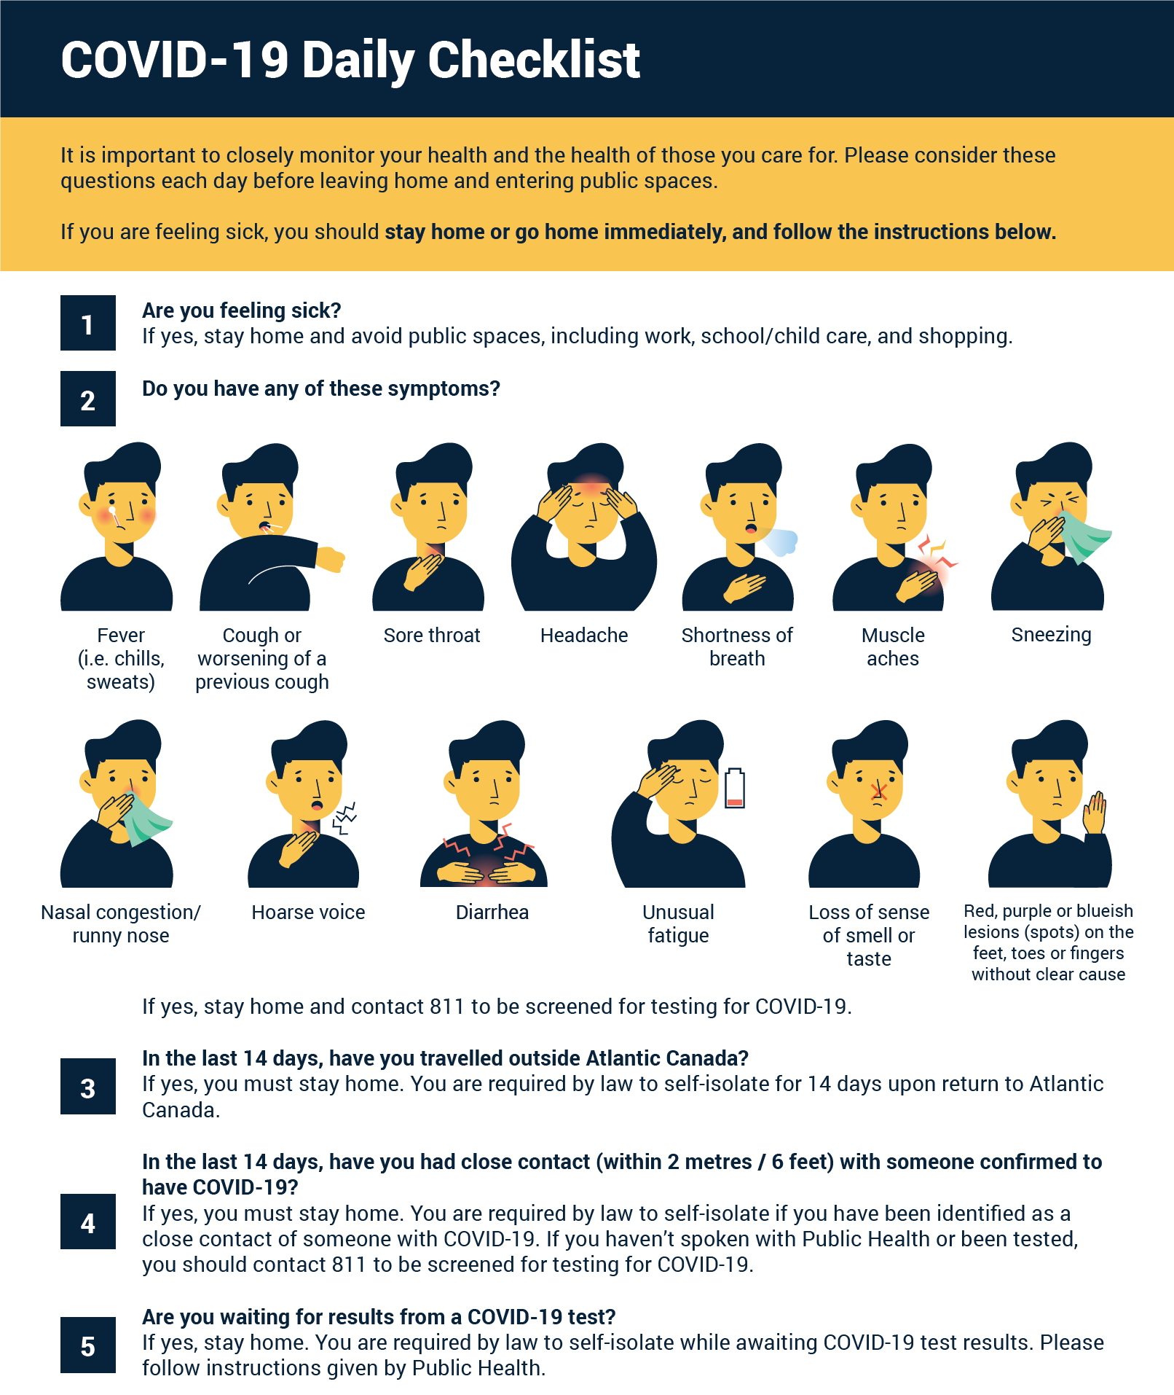

**Signage in the school**

The Operations Department has supplied us with the following signage and it has been placed throughout the school:



Thank you for taking the time to read through this document. We are doing everything we can to ensure your child’s safety. Please contact me if you have any questions.

Nancy Liberatore  
Principal  
[nliberatore@hrce.ca](mailto:nliberatore@hrce.ca)  
902-465-8651 ext. 2